**DAY-9**

1. **Set add() method:**

It adds a given element to a set if the element is not present in the set

**Syntax:** set.add( element )

1. 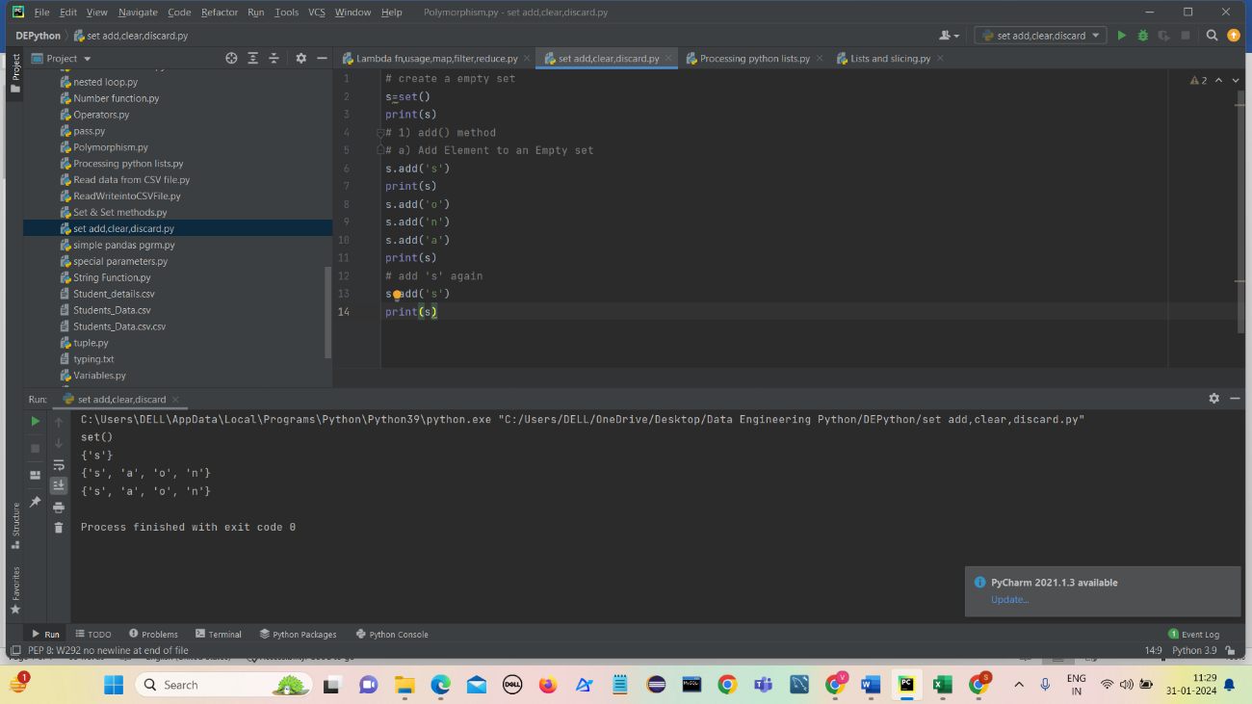**Add element to an empty set**
2. **Add a new element to a Python set**

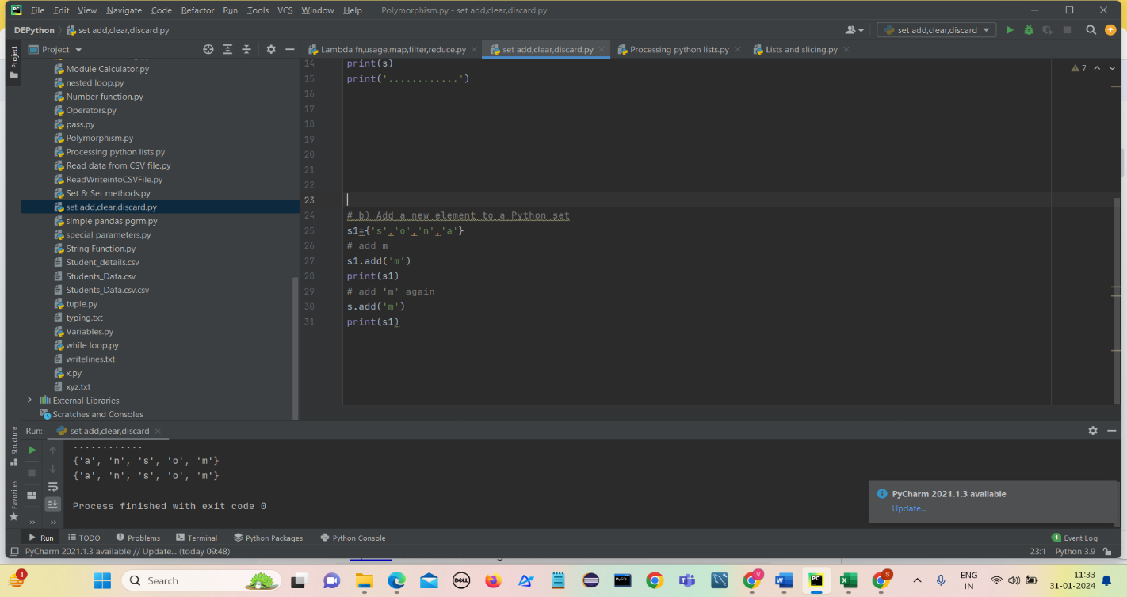It is used to add a new element to the set if it is not existing in a set.

An element is added only if it is not present in the set else element doesn’t get added since set doesn’t allow duplicate elements.

1. **Add element in a set that already exists**

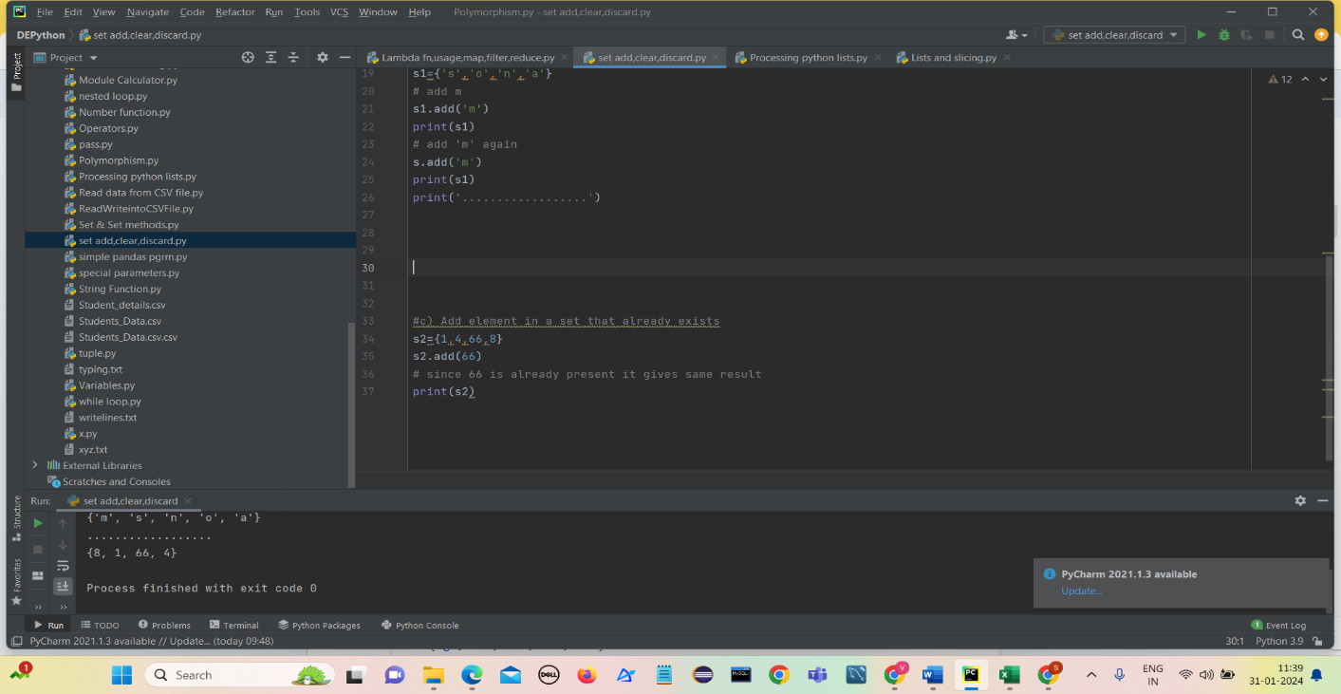It is used to add an existing element to the set if it is existing in the Python set and check if it gets added or not.

1. **Adding any iterable to set**

We can add any Python iterable to a set using Python add or Python update function.

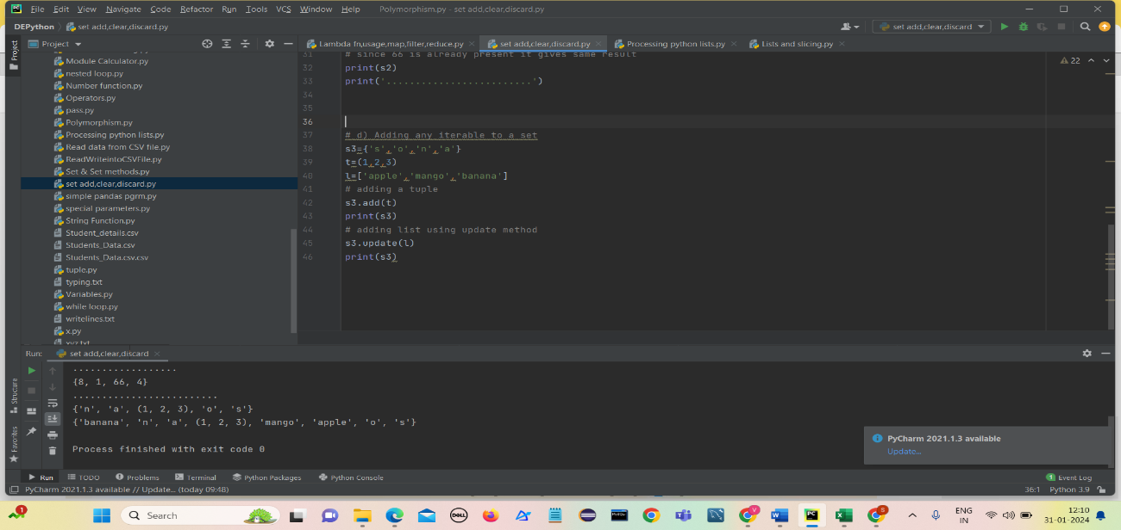We can add tuple using add() method an list using update() method

1. **Set clear() method:**

Set clear() method removes all elements from the set and it doesnot take any parameters.

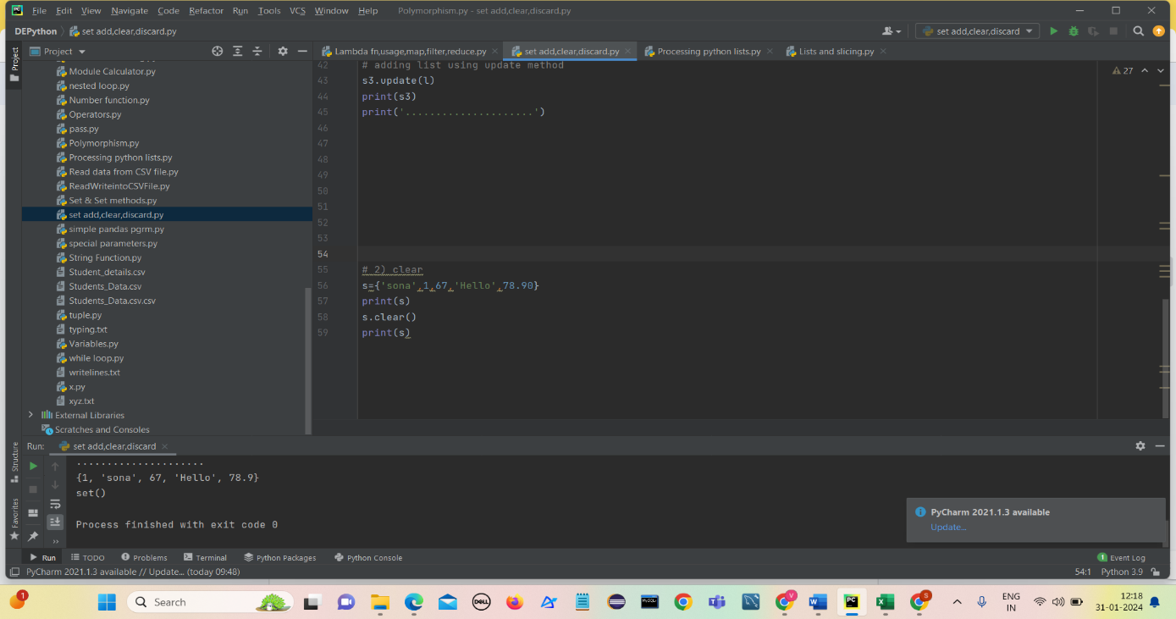**Syntax**: set_name.clear()

1. **Set copy() method:**

The copy() method returns a shallow copy of the set in python.

When we modify something in the copied set, changes are not reflected back in the original set.

**Syntax:** *set_name*.copy()

**Parameters:** The copy() method for sets doesn’t take any parameters.

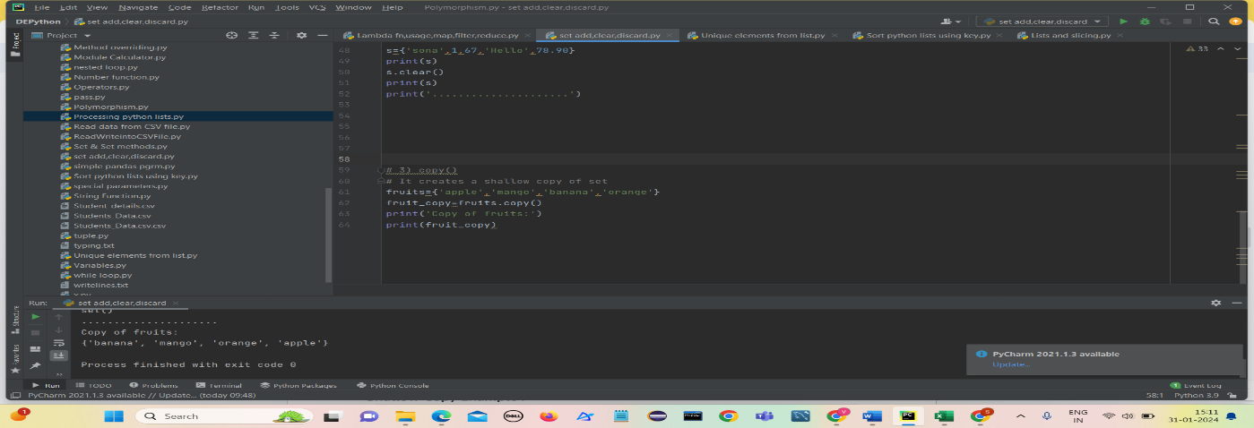**Return value:** The function returns a shallow copy of the original set.

**Shallow Copy Example :**

Python program to demonstrate copy created is shallow

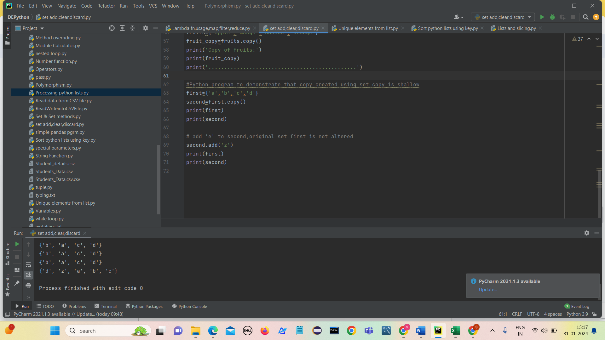

When we modify something in the copied set(second), changes are not reflected back in the original set(first).

1. **Set discard method():**

* Python **discard()** is a built-in method to remove elements from the set.
* The **discard()** method takes exactly one argument.
* This method does not return any value.

**Syntax**

set.discard(element)

**Parameter**: element – an item to remove from the set.

**ReturnValue** : return  – discard() method doesn’t return any value.

If we discard any element that is not existing in the set, it doesn’t give any error.

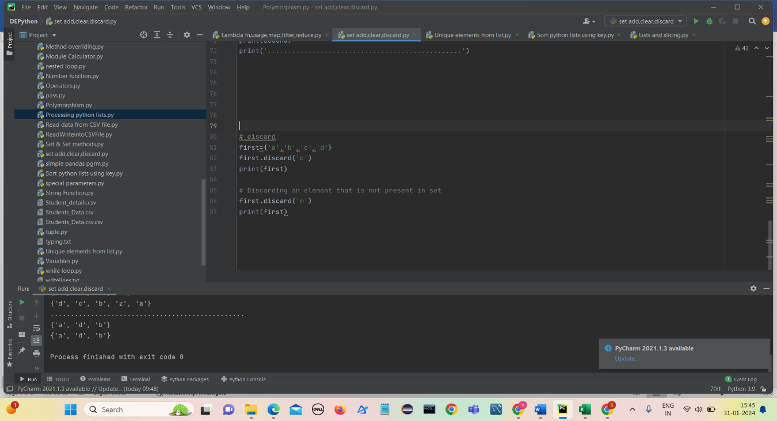

**Get unique elements from the list**

1. **Using set Method:**

* Insert the values of the list in a set.(convert the list into set)
* Set doesn’t allow duplicate values
* Now convert the set into list again and this resulted list contains all unique elements.

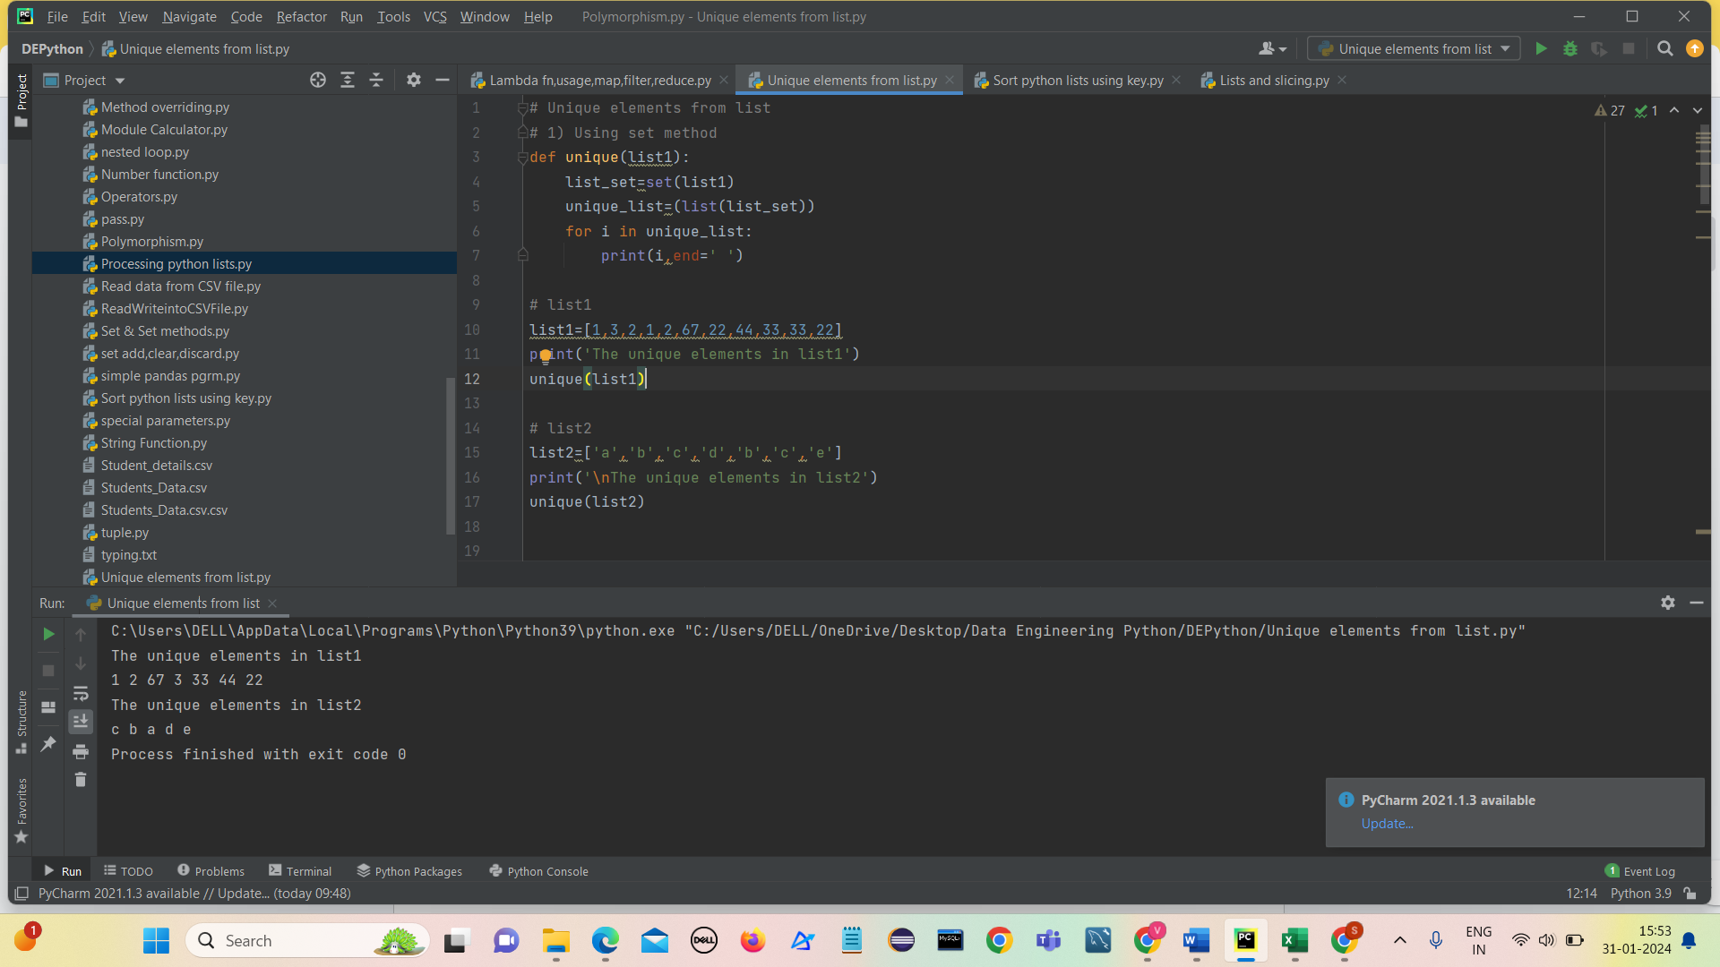

1. 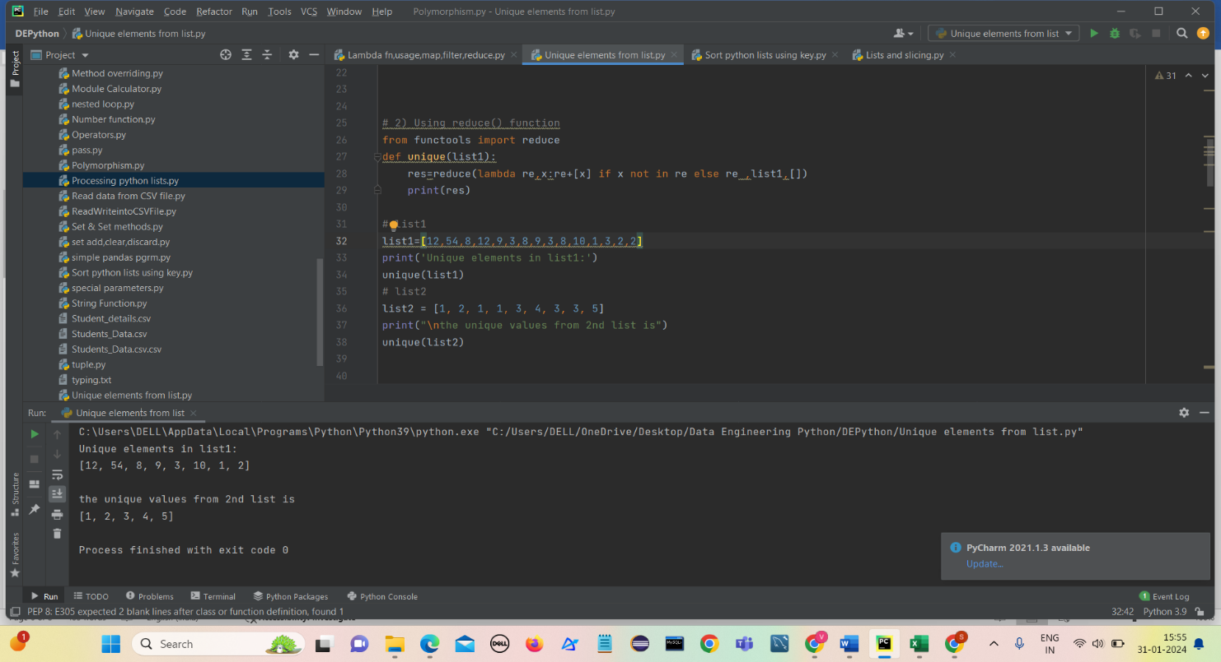**Using reduce() function**

* **reduce()** takes three arguments: a function (lambda function), an iterable (**list1**), and an initial value (**[]**).
* The lambda function takes two arguments **re** (which accumulates the result) and **x** (the current element from the list).
* Inside the lambda function, **re+[x]** appends the current element to the accumulator list **re** if **x** is not already in **re**, effectively filtering out duplicates.
* If **x** is already in **re**, the lambda function returns **re** unchanged.
* **reduce()** iterates through the elements of **list1**, applying the lambda function to each element and accumulating the result.
* The initial value **[]** initializes the accumulator **re** as an empty list.
* The final result is the list of unique elements.

1. **Using Operator.countOf() method**

* import operator as op
* initialize a empty list(unique_list)
* traverse all elements
* using countOf() check if element is present in unique_list
* If countOf is 0 append that element to unique_list
* 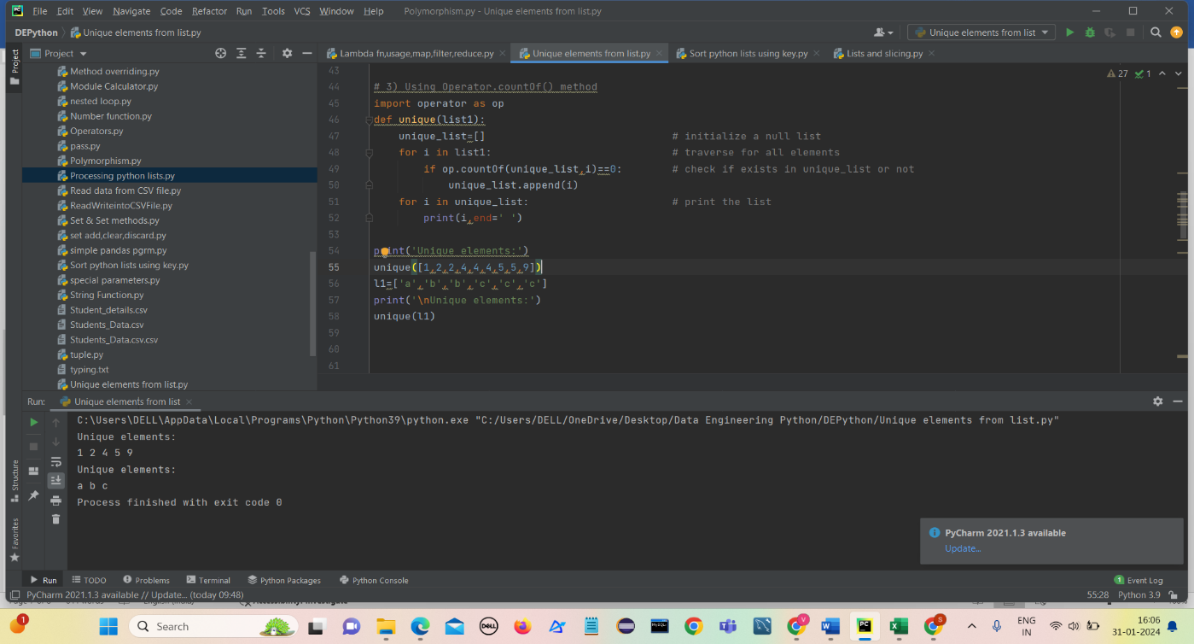Print all the elements in the end which are all unique elements.

1. **Using Pandas module**

* The ‘unique’ function utilizes Pandas to create a Series from ‘list1’
* It then employs ‘drop_duplicates()’ to eliminate duplicates and obtain a list of unique values.
* Finally it iterates through the unique list and prints each element.

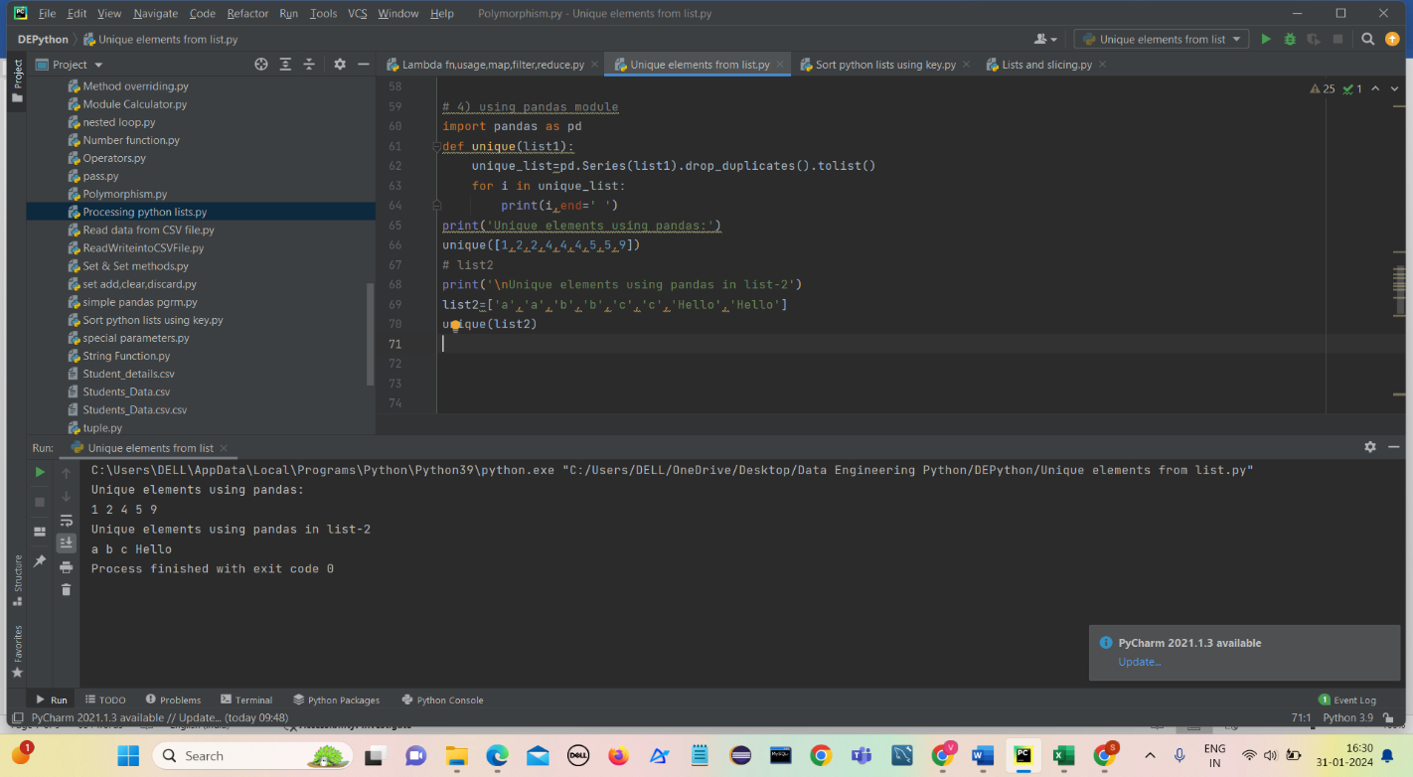

1. **Using collections.Counter()**

* import Counter() from collections
* print all the keys of Counter elements

or

* 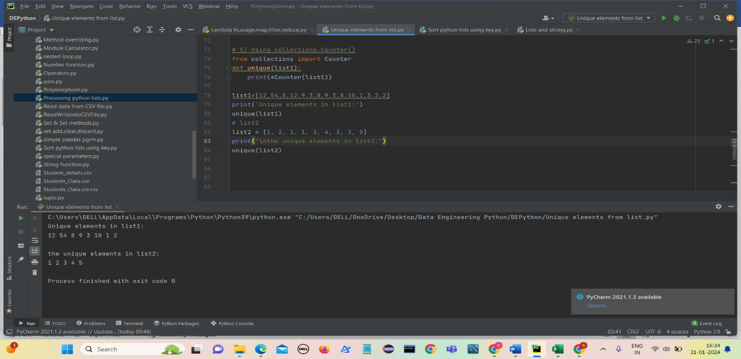we can print directly by using the * symbol.

1. **Using dict.fromkeys()**

* First define a list that consists of duplicate elements.
* Then we need to use a variable in which we will store the result after using the fromkeys() method.
* We need to convert that result into a list
* fromkeys() method is part of the dictionary so by default it returns a dictionary with all the unique keys and None as their values.
* Keys in dictionary cannot have duplicate values.

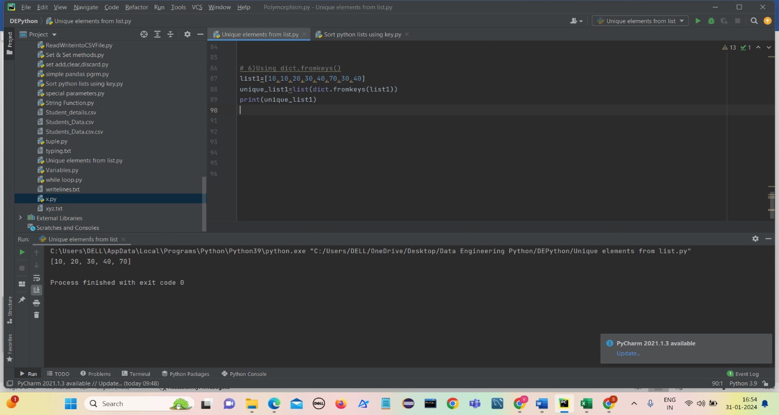

1. 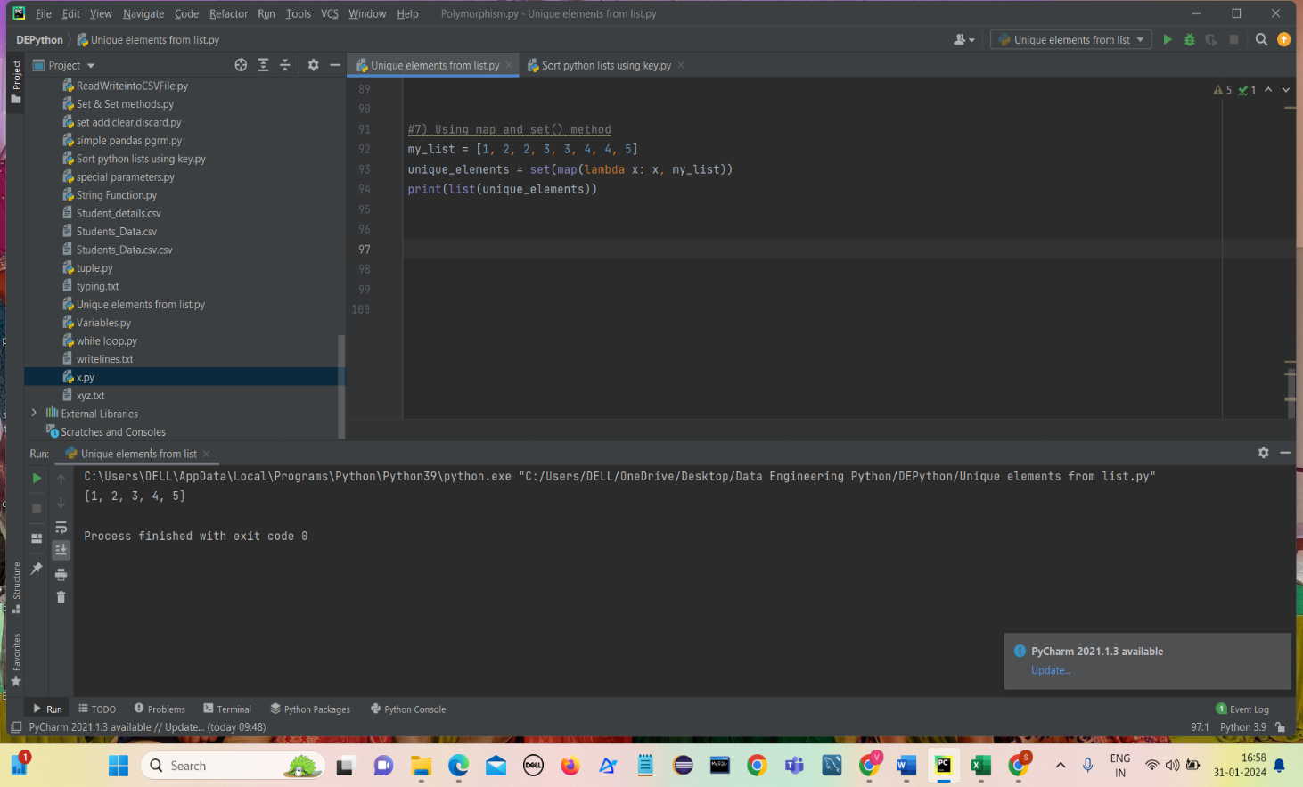**Using map and set() method**

**Sorting python Lists**

* sorted(list) function takes a list and returns a new list with those elements in sorted order and the original list is not changed.
* The sorted() function can be customized through optional arguments.
* The sorted() optional argument reverse=True, e.g. sorted(list, reverse=True), makes it sort backwards.

1. Using sorted() function
2. Using sorted(reverse=True)
3. 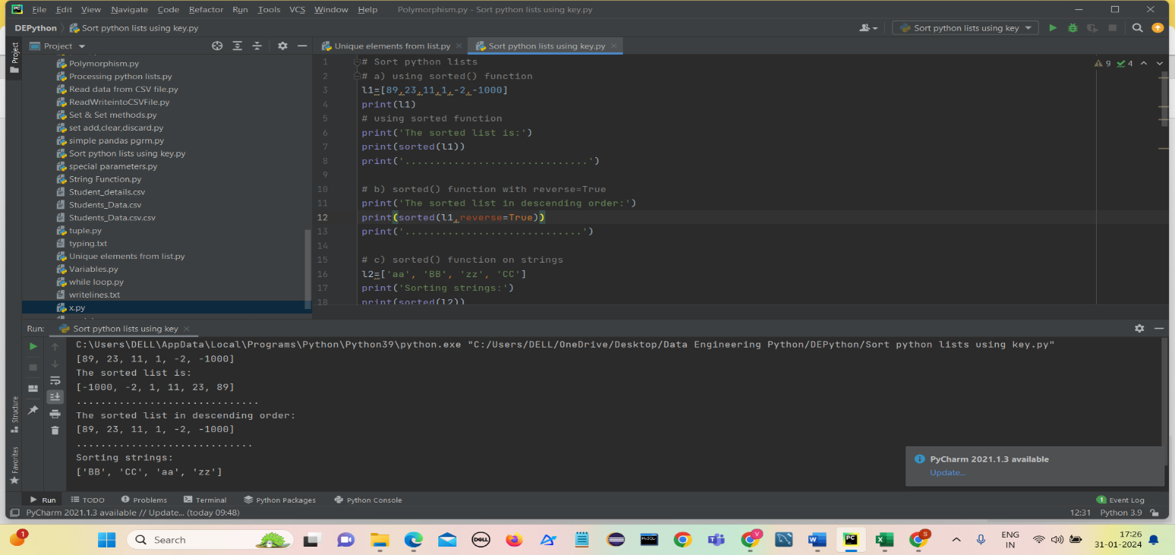Using sorted() function on strings

Using sorted(reverse=True) returns elements in Descending order.

**Custom Sorting With key=**

* For more complex custom sorting, sorted() takes an optional "key=" specifying a "key" function .
* It transforms each element before comparison.
* The key function takes in 1 value and returns 1 value
* The returned "proxy" value is used for the comparisons within the sort.

1. **key=len()**

* key=len (the built in len() function) sorts the strings by length, from shortest to longest.
* 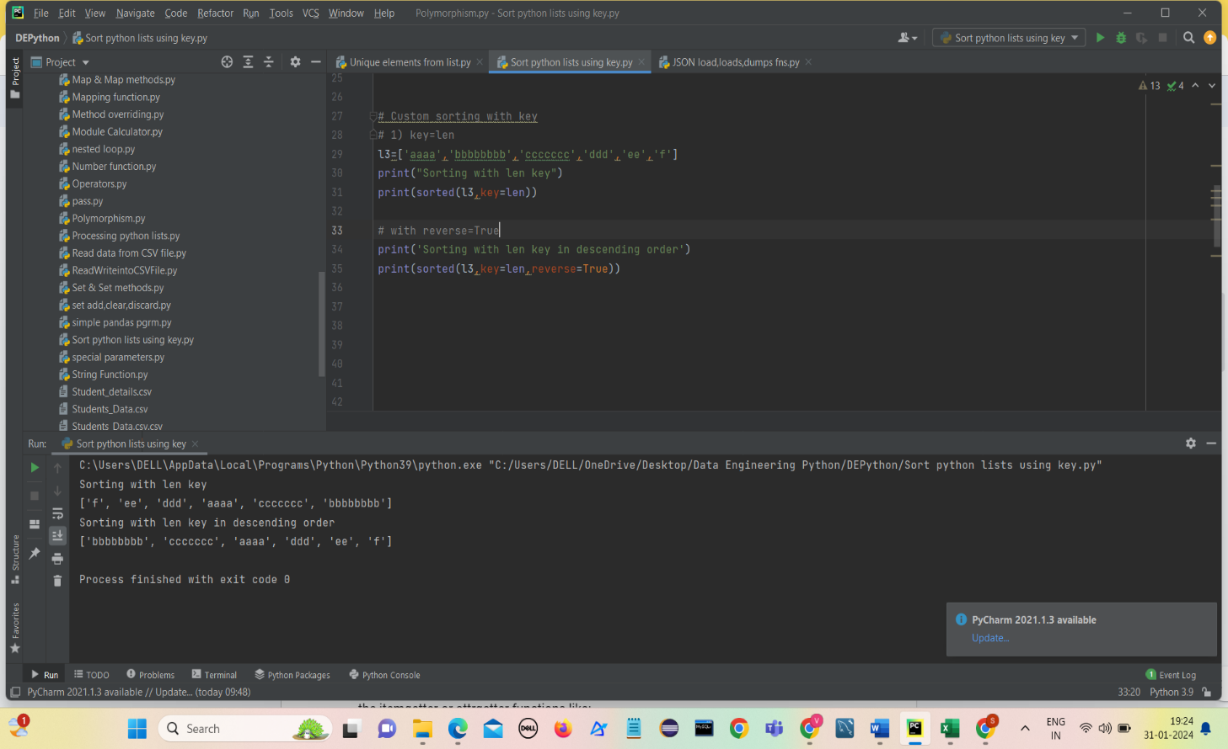The sort calls len() for each string to get the list of proxy length values, and then sorts with those proxy values.

1. **key=str.lower()**

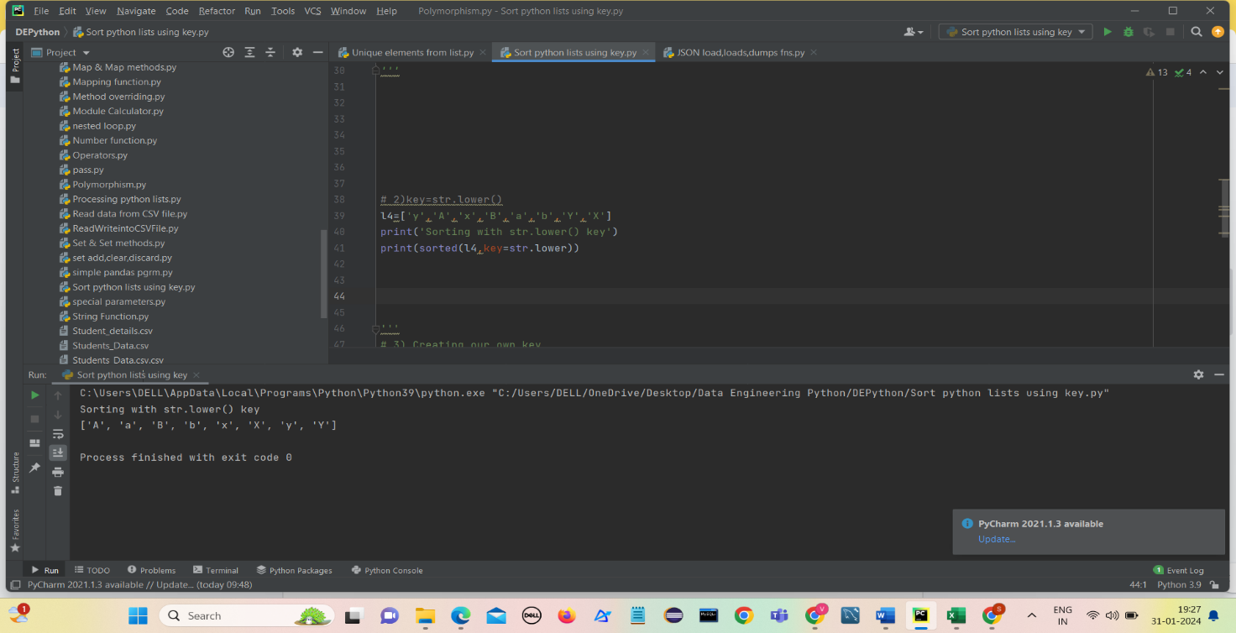Key function is a way to force the sorting to treat uppercase and lowercase the same.

1. 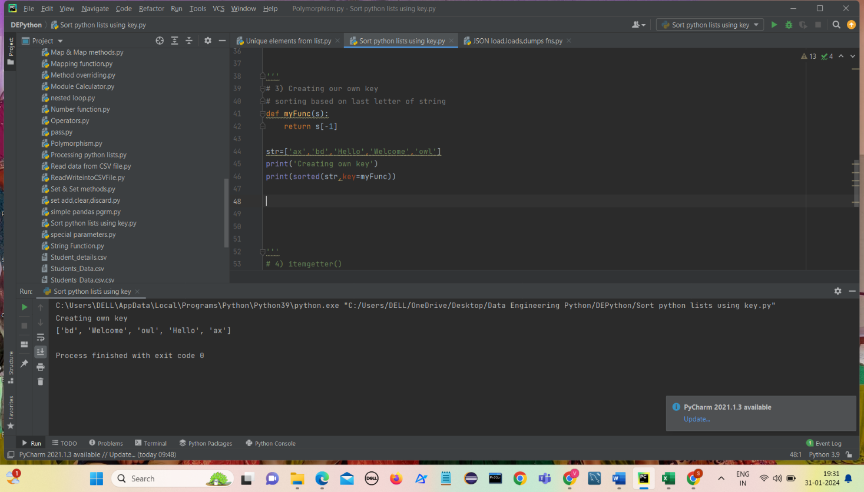**Creating our own key  
   Sorting based on last letter of string**

**itemgetter()**

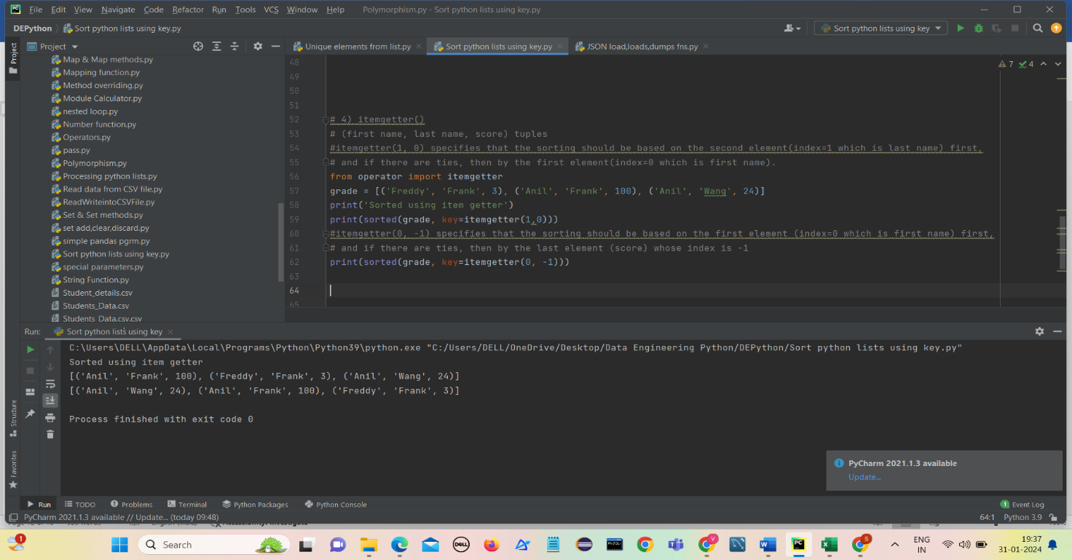(firstname , lastname, score) tuples

itemgetter (1,0) specifies that sorting should be based on the second element(index=1 which is last name) first, and if there are ties, then by the first element(index=0 which is first name)

itemgetter (0,-1) specifies that sorting should be based on thefirst element(index=0 which is first name) first, and if there are ties, then by the last element(index=-1 which is score)

**sort():**

* sort() method on a list sorts that list into ascending order, e.g. list.sort().
* The sort() method changes the underlying list and returns None.

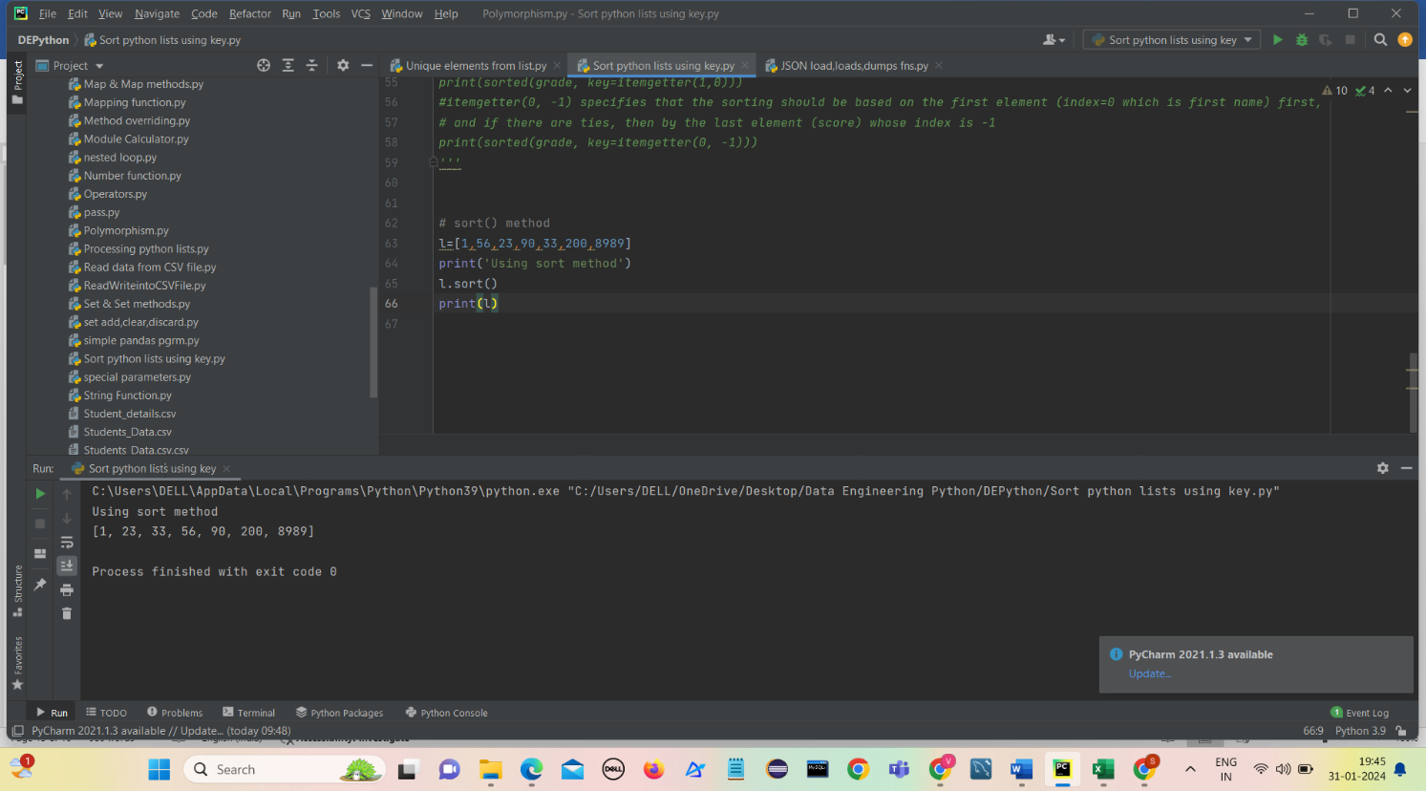

**JSON**

* **JSON** stands for **J**ava**S**cript **O**bject **N**otation. It is a format for structuring data.
* This format is used by different web applications to communicate with each other.
* JSON is the replacement of the XML data exchange format in JSON.
* It is easy to struct the data compare to XML.
* It supports data structures like arrays and objects and the JSON documents that are rapidly executed on the server.
* It is also a Language-Independent format that is derived from JavaScript.

**Features of JSON:**

* Easy to understand
* Format
* Support
* Dependency

**Example of JSON String**

s = '{"id":01, "name": "Emily", "language": ["C++", "Python"]}'

The syntax of JSON is considered a subset of the syntax of JavaScript including the following:

1. **Name/Value pairs:** Represents Data, the name is followed by a colon(**:**), and the Name/Value pairs are separated by a comma(**,**).
2. **Curly braces:** Holds objects.
3. **Square brackets:** Hold arrays with values separated by a comma (**,**).

**Example of JSON file:**

 {  
    "employee": [  
   {  
      "id": "01",  
      "name": "Amit",  
          "department": "Sales"  
   },  
   {  
      "id": "04",  
      "name": "sunil",  
          "department": "HR"  
   }  
    ]  
 }

**Convert JSON String to Dictionary Python**

Json.loads(): converts JSON string into Python Dictionary

* import json module .
* Define JSON .
* Convert JSON string to Python dictionary by passing it to json.loads() in parameter.
* 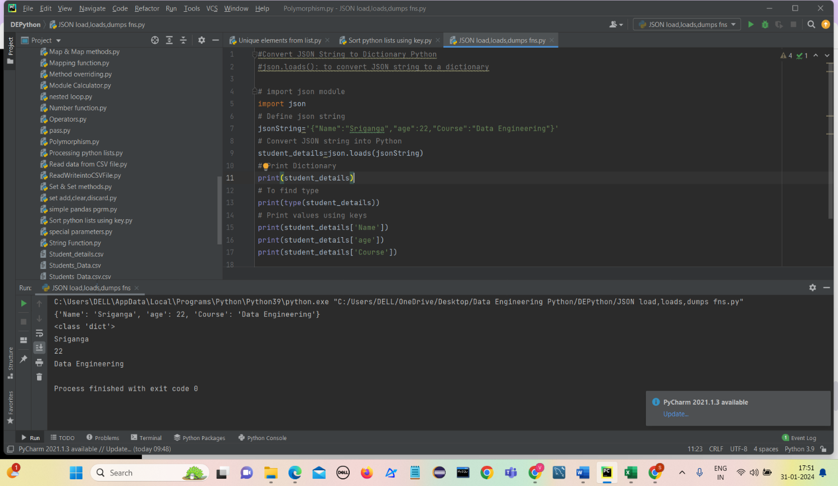Print the dictionary and their values using the keys.

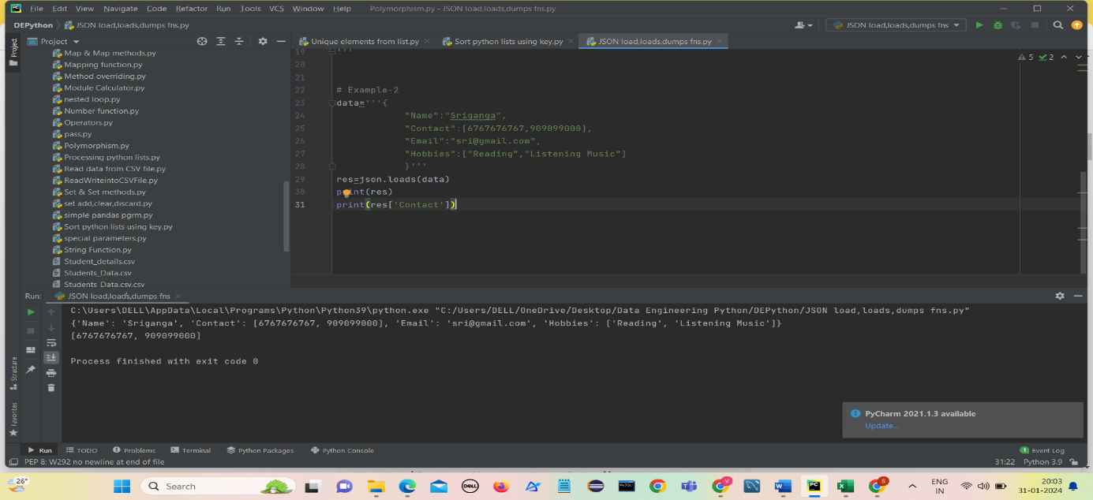**Example-2**

**Convert JSON File to Python Object**

Json.load()- It accepts a file object and read JSON data from a file and convert it into a dictionary.

* open the “data.json” file
* convert the file to Python object using the json.load() method
* print the type of data after conversion
* 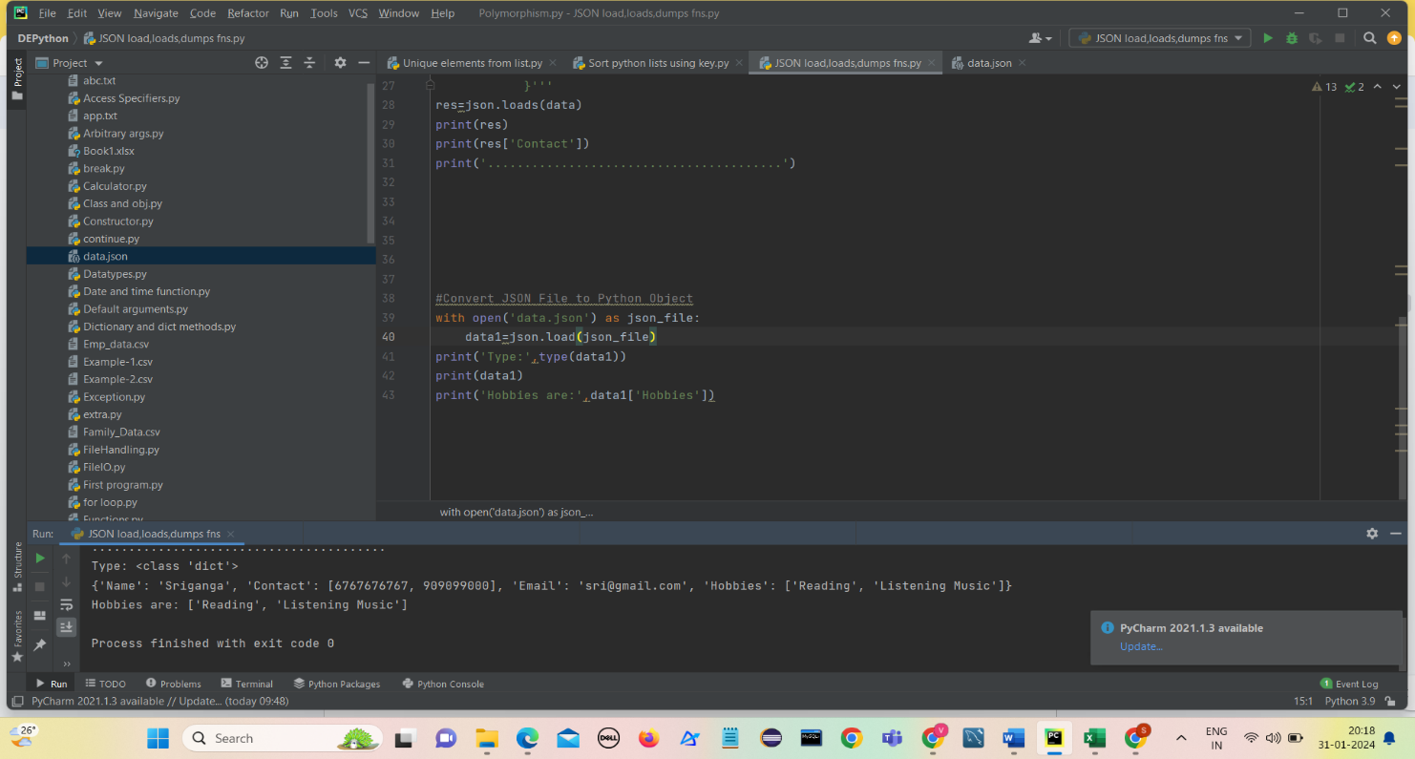print the dictionary.

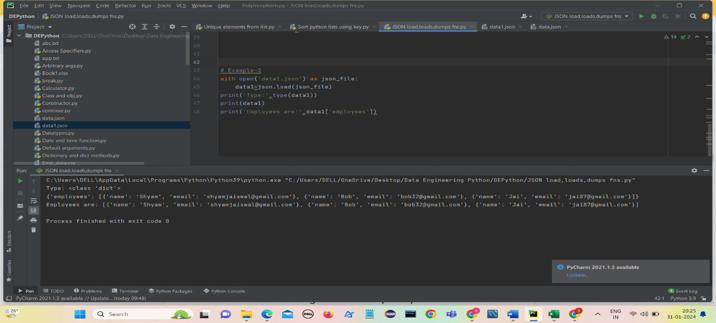**Example-2**

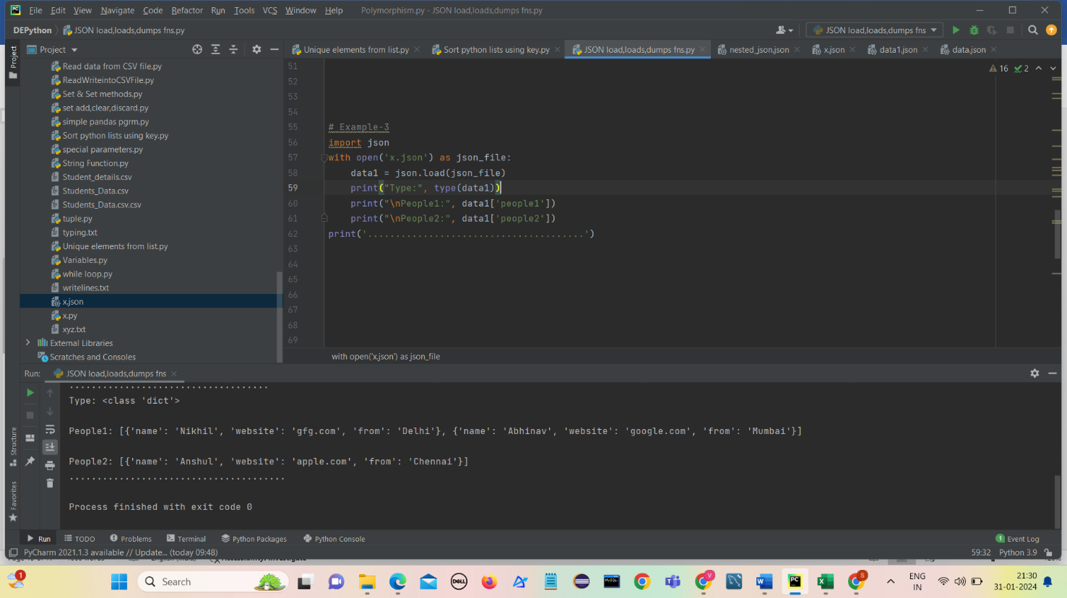**Example-3**

**Convert Nested JSON Object to Dictionary**

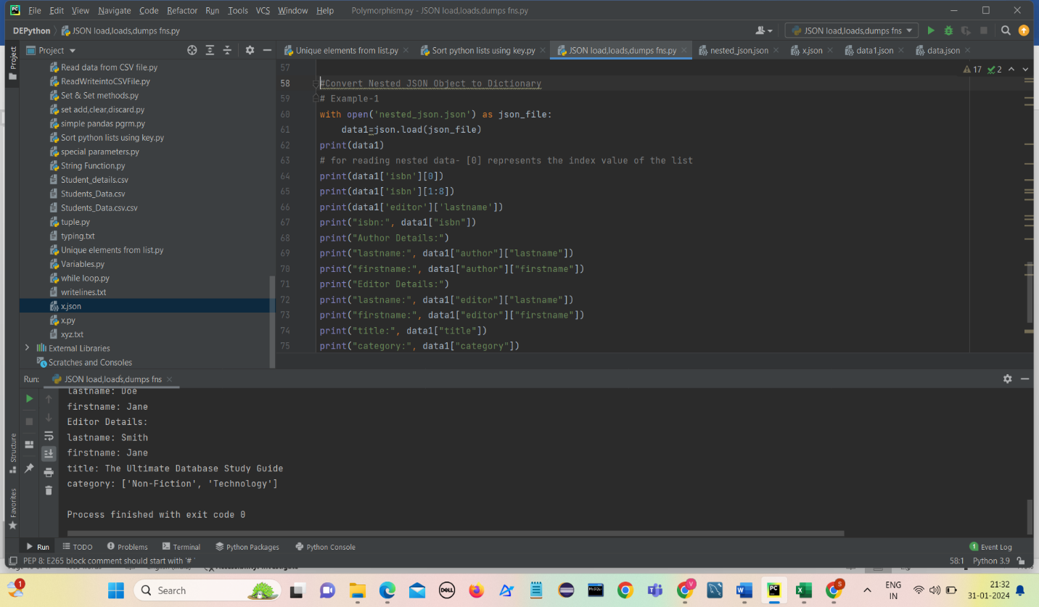In this example, we will convert the nested JSON into a Python dictionary.

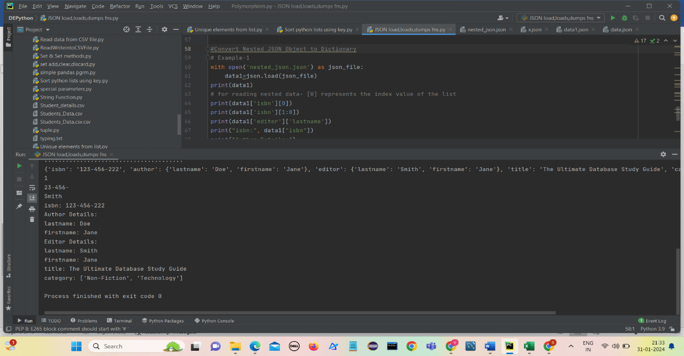

**Example-2**

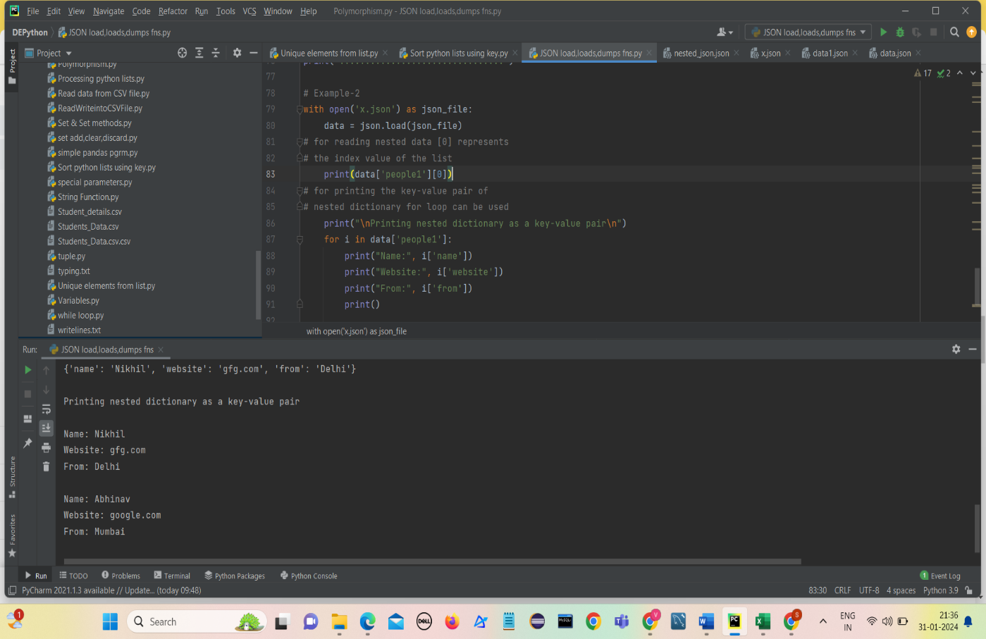

**Read, Write and Parse JSON using Python**

1. **Python read JSON file**

* We have used the open() function to read the JSON file.
* 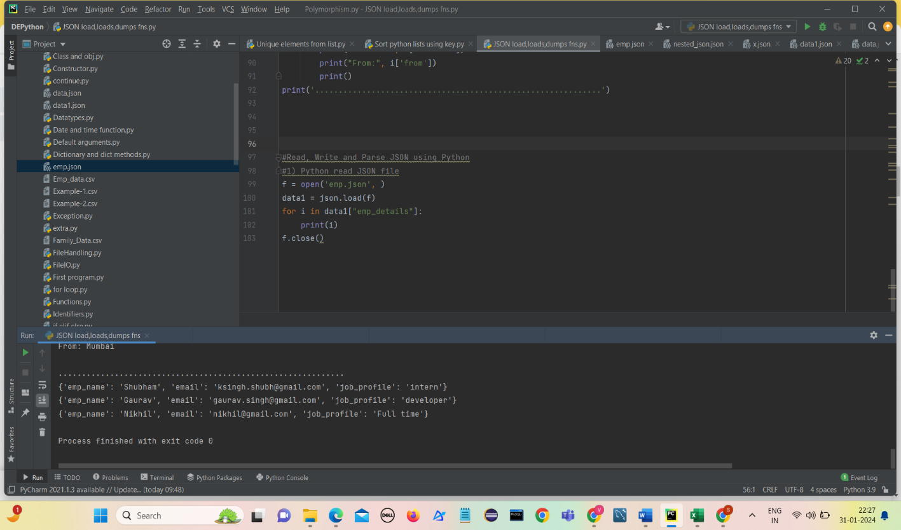Then, the file is parsed using json.load() method which gives us a dictionary named data.

1. **Convert Python Dict to JSON**

* We are converting a Python dictionary to a JSON object using **json.dumps()** method
* make a small dictionary with some key-value pairs and then passed it into json.dumps() method with ‘indent=4’ to convert this Python dictionary into a JSON object.
* As we have given the value of indent to 4 there are four whitespaces before each data as seen in the output.

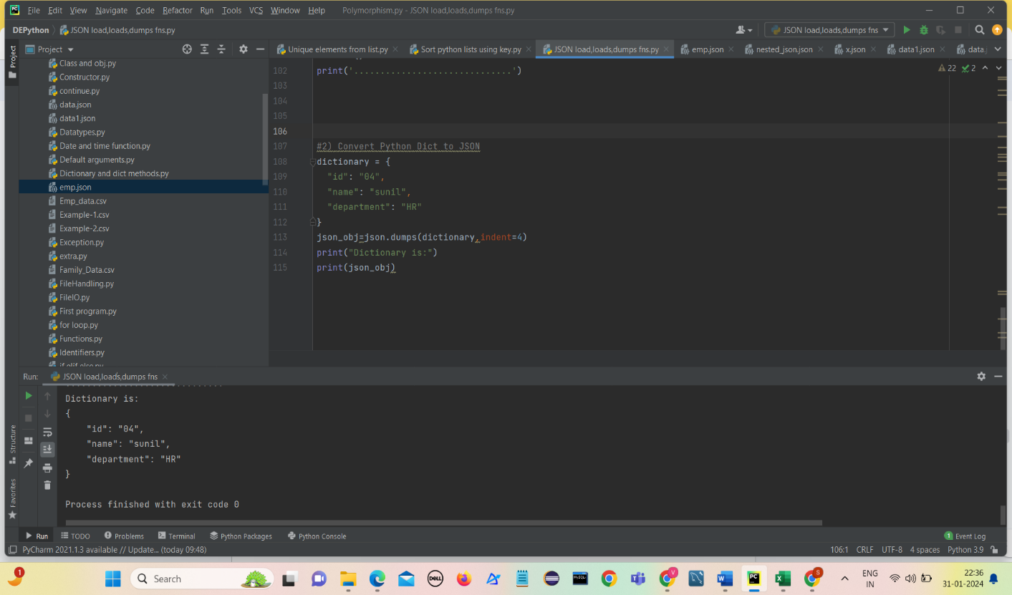

1. **Writing JSON to a file in Python**

* We can write JSON to file using json.dump() function of JSON module and file handling in Python.
* In the below program, we have opened a file named sample.json in writing mode using **‘w’**.
* The file will be created if it does not exist.
* Json.dump() will transform the Python dictionary to a JSON string and it will be saved in the file sample.json.

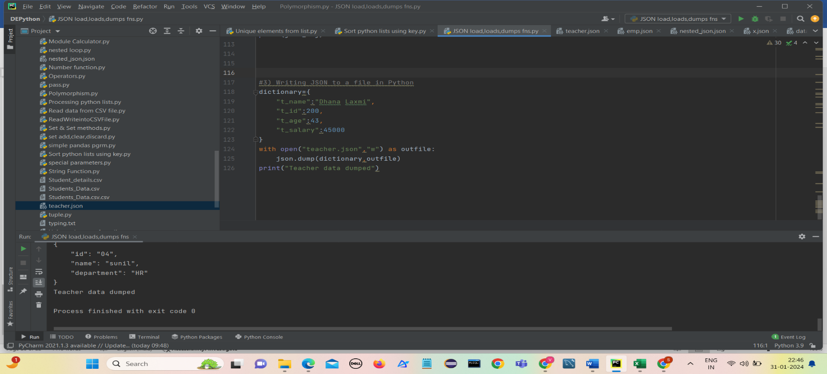A new file teacher.json is created and data is written into it

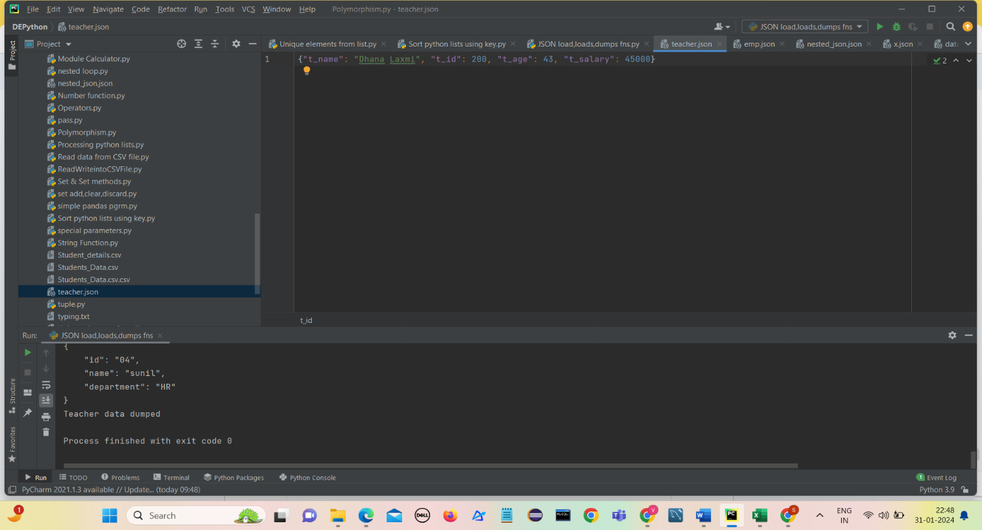

1. **Python Pretty Print JSON**

* When we convert a string to JSON the data is in a less readable format.
* To make it more readable we can use pretty printing by passing additional arguments in json.dumps() function such as **indent** and **sort_keys** as used

